ATHLETE GUIDE
TRI for HEROS

September 28th, 2019

Dear Athlete,
Welcome to the Tri for Heros First Heroes Tour! This letter will go through some of the important parts of the race, and hopefully answer your questions. Please read over the whole document and contact us with any concerns you might have. We look forward to seeing you on Saturday, September 28th!

While the weather forecast looks great and September in Massachusetts is generally pleasant, sometimes we have less-than-ideal conditions. Please note that the event will not be cancelled for any reason other then severe conditions that pose extreme danger to athletes and volunteers. Race management reserves the right to alter the course whatever way they deem is in the best interest of the athletes and volunteers. This includes, but is not limited to, shortening or changing the course, removing one of the sports, postponing the start, etc.

Volunteers are still needed for the Tri for Heros, First Heroes Tour. If you know someone who wants to be a volunteer, please have him or her e-mail cmarden@triforheros.org. All volunteers will receive a t-shirt, coffee, and snacks/BBQ. Please be sure to thank volunteers who are working the event. Without them, the race could never happen!

The Tri for Heros, First Heroes Tour promises to be a fun and exciting event. We are looking forward to hosting athletes and heroes from across New England as well as visiting heroes in this great experience. Thanks again for registering and we can’t wait to see you on the 28th of September.

P.S. Please bring a patch from your unit/ department to be proudly displayed on the wall of patches featured at the finish of the race.

Thank you to all our 2019 Sponsors and partners!
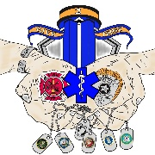

EVENT SCHEDULE

Thursday, September 26th
11:00 am Packet pickup in Norwell at Marathons Sports
(134 Washington Street)
2:00 pm Packet pickup ends

Friday, September 27th
11:00 am Packet pickup in Plymouth at Marathon Sports
(38 Long Pond Rd)
2:00 pm Packet Pickup ends

Saturday, September 28th
6:15 am Packet Pickup and same day registration at Charge Pond, DCR Plymouth MA.
6:30 am Transition areas and bag check opens
7:45 am Travel restricted on main road for kids’ mile fun run
8:00 am Junior Heros fun run begins
8:30 am Junior Heros fun run ends
8:45 am Transition area closes and packet pickup ends
8:50 am Opening remarks and safety brief (will be conducted for every wave)
9:00 am First wave
2:00 pm Awards ceremony (approximate time)
2:15 pm BBQ

Race Packet Pick up
Before you can compete in Tri for Hero’s, First Heroes Tour you must pick up your official race packet. There are three available times you can do this:
Thursday, September 26th from 11:00 am to 2:00 pm at Marathons Sports located at 134 Washington St, Norwell, MA 02061. Please keep in mind that the store staff are not involved with the race planning, so its best to direct your race questions towards us.
Friday, September 27th from 11:00 am to 2:00 pm at Marathons Sports located at 38 Long Pond Rd, Plymouth, MA 02360.
Saturday, September 28th from 6:15 am to 8:45 am at Charge Pond, DCR Myles Standish State Forest, located in Plymouth MA.
You can pickup your teams’ packets but must have proof that the other athlete/hero consents.
Bring your Photo ID with you to register/ pickup! You are REQUIRED to show it when you sign in. NO EXEPTIONS.
You will receive a race packet that contains a run number, a bike number, safety pins, a swim cap, and other goodies. If you pick up at a Marathons Sports you will receive Marathon Sports coupons. Please double check that you have everything before you leave packet pickup and please check the information on you packet!

Directions to:
Charge Pond, DCR Myles Standish State Forest, Plymouth MA.
From Boston Area Route 93 to Route 3 South:
- Take Route 3 south to exit 5
- Bare right off ramp onto Long Pond Rd travel 3.8 miles on Long Pond Rd.
- Turn Right onto Alden Rd at forest entrance travel 1.8 miles on Alden Rd to fork in road.
- At fork in road (Upper College Pond Rd and Lower College Pond Rd) Bare left onto Upper College Pond Rd.
Follow signs to Charge Pond.
- Travel approx. 3 miles on Upper College Pond Rd to the end (passing parking lot & Halfway Pond Rd)
Follow signs to Charge Pond.
- At Stop sign (end of Upper College Pond Rd) turn left onto Fearing Pond Rd travel 0.7 of a mile.
Follow signs to Charge Pond
- Turn right onto Charge Pond Rd travel approx. 1.5 miles ahead will be volunteers to show you into a parking space.

(cont) Directions to:
Charge Pond, DCR Myles Standish State Forest, Plymouth MA.
From Route 495:
- Take Route 495 South to Exit 2 (follow signs to Myles Standish State Forest)
- Take a left off the ramp and go 3 miles, you are on Rt. 58/Tremont Rd in Carver (you will pass a dunkin donuts on right, and Erickson’s Ice Cream on left and Dave package store)
- Bare right at Dave’s package store (you’re still on Tremont Rd)
- Take second right onto Cranberry Rd
- Stay on Cranberry Rd for 3 miles to the very end (Myles Standish HQ is the building with 3 flag poles in front)
Follow signs to Charge Pond
- From the Myles Standish HQ, take a left -heading North on Lower College Pond Rd. – at fork, bear right onto Halfway Pond Rd. At the Stop sign, take a right onto Upper College Pond Rd (stay on Upper College Pond Rd to very end)
Follow signs to Charge Pond
- At end of Upper College Pond Rd Turn left onto Fearing Pond Rd. Travel 0.7 of a mile.
Follow signs to Charge Pond
- Turn right onto Charge Pond Rd. Travel approx. 1.5 miles, ahead will be volunteers to show you into a parking space.

Parking
As you approach Charge Pond there will be a sign directing all vehicles to turn right onto Charge Pond. From here a parking guide will direct you where to go.
Reminder – All vehicle must be parked, and equipment laid out in the appropriate transition areas prior to 8:45 AM.

Race Day To-Do list
If you have not signed in before race day, we recommend that you do the following things, in this order:
- Park your vehicle in the appropriate lot. You will be greeted by a volunteer upon your arrival and assisted where to park.
- Carry all you gear to packet pickup
- If you need to pick up your race packet, proceed to the pickup/registration tent inside the “compound” and pick up your packet. *
- Proceed to the transition area and stage your gear.
*If you have already picked up your packet, you should go straight to the transition area.

Race Day Packet Pick-up
Packet pick-up begins at 6:15 AM on Saturday inside the “compound” near the pavilion at Charge Pond. It ends at 8:45 AM.
Transition Area, Pre-Race Meeting
The Transition Area will be open at 6:30 AM on Saturday and will close 15 minutes prior to the start. All athletes, including relay members, must have athlete identification to participate. There will be a mandatory pre-race meeting 10 minutes prior to your wave on the beach. The first swim wave will start at 09:00 AM.

Race Numbers
You are required to display your race number while competing. This is both for safety and to make sure our volunteers can see you for back-up timing.
For the swim leg, your number will be written on your body or identified by a bracelet.
The bike leg requires your number to be displayed from either the front or the back but must be clearly visible. Numbers also help the photographers to identify your pictures. If they can’t see your number, your picture will most likely not be matched with you.
During the Ruck, your Race number must be displayed from the front. This is especially important for the finish. If you are planning on wearing layers and taking them off as you go, find a way of displaying your number the entire time. A good option is to use a race number belt that you can clip and unclip very easily.

RACE INFO
Swim
The swim is a clockwise circular course that starts and finishes on the beach. The conditions are clam, and the water is typically in the mid 60’s. There will be buoys and soft barriers marking the course.

REMEMBER – Safety First! There will be watercrafts in the pond with lifeguards monitoring the race. If you need assistance during the swim, raise your arm in the air, or swim to the nearest kayak/boat. You can stop and rest on the boat without a penalty as long as you don’t make any forward progress while receiving assistance.

After the AM pre-race meeting, volunteers will stage participants into waves. Each wave is marked by a different color wristband. You will be assigned a wave based on your age and/or category.
*Please note that the wave assignments and start times are subject to change.
Transition Area
You will be assigned to a specific bike rack based on your race number. If you put your bike in the incorrect spot, it will be moved to the correct spot, and we’ll try to notify you (but that cant be guaranteed) or you may be given a time penalty. You may not use balloons to mark your spot because of the danger they pose when there is wind. No one is allowed into the transition areas except athletes and race staff/volunteers at any time! You must be marked with your number in order to enter the transition area before the race, and to check your bike out after the race.

Since the transition area has such high traffic, you must always be aware of other athletes and their space. Please do not move anyone else’s belongings without permission and do not let your belongings take up more then your fair share of space (typically a couple of feet on one side of your bike). When you are ready to begin the bike leg of the race, exit out the opposite end of the transition area where you entered. The exit will be clearly marked. You may not ride your bike until you have exited the transition area and reached the designated mount/dismount line.

You MUST have your helmet buckled before you get on your bike. if you mount your bike without your helmet fastened on your head, you risk disqualification. The same is true of you take your helmet off before you dismount your bike. When you return from the paths, you must re-rack your bike in the same spot where it was originally racked. It is a very good idea to understand the flow of the transition area before the race begins.

Mountain Bike
The Hero bike course will be a 3.1-mile loop course with varied terrain, including hardball road, sand, dirt, and rocks. The Super Hero bike course is a 6.2-mile loop. There is only 1 aid station on the bike course location at the Hero and Super Hero split. The course will be marked with arrows, signs, and cones. Please exercise caution while biking and keep your speed under control. If you fall of your bike, pull your bike out of the way and wait until it is safe to re-enter the course.

The roads in and around the venue area will be closed to vehicles during all the bike leg portion. Once the last biker crosses enter the transition area the roads will partially open, with police/volunteers controlling traffic flow. Please pay attention to all volunteer’s directions and warnings about upcoming changes. If you have bike trouble, please notify the nearest volunteer, but be advised that because the trail is inaccessible by vehicle you may have to drop from the bike leg or pull out of the way while fixing any issues that occurred.

Because there is only one water station on the bike course. Plan to bring whatever water you will need for the ride. When you finish the ride, you must dismount your bike at the dismount line, and make your way to the transition area. Remember-rack your bike in the same spot it was in before.
All athletes should complete the bike course within 2 hours from the start of the last swim wave.

Ruck
The Ruck is a multi out-and-back course on a paved trail, finishing at the “compound”. Follow the volunteers, signs, and arrows that are marking the route. Water and electrolyte replacement (Gatorade) drink will be available at turn around points. Rucker’s will be separated by cones while on major roads. While inside the coned lane rucker’s should stay to the left side and be aware that other rucker’s may be coming from the opposite direction. IMPORTANT: Super Hero Ruck mileage is classified to create simulated mental stressors/endurance. If at any point you must drop out tell the nearest Volunteer.

Rucks may vary in weight by comfort, however the standard for Super Hero is 30lbs and the standard for Hero is 15lbs. Participants that are competing for a podium spot must have the minimum weight indicated above.

**all course maps can be found at the end of this guide

POST-RACE
Following the race there will be a BBQ with some light snacks available for all competitors. There may be a small number of tickets still available. Please ask after the race.

The transition area will be open following the last cyclist. Please do not ask to retrieve your gear before that time, out of respect for the athletes who are still competing. If you are prone to getting chilly, plan ahead and store any warm clothes outside of the transition area, or inside your Ruck/backpack.

Photography
Look for photos on our website, Facebook page, and follow-up email for information on complimentary photos sponsored by Joseph Strigle Photography.

Inclement Weather
Tri for Heros will not be cancelled for any reason other then severe conditions that pose extreme danger to athletes and volunteers. Race Management reserves the right to alter the course in whatever way they deem is in the best interest of the athletes and volunteers. This includes, but not limited to, shortening or changing the course, removing one of the sports, postponing the start, etc. There are no refunds in the case of weather caused changed or cancellations, however the event will one be cancelled if the weather poses a danger to participants or volunteers.
First Aid
Medics will be on scene as well as lifeguards, first responders and volunteers. If at any point during the race you have a medical concern, notify the race officials or a volunteer immediately for assistance. There will be an ambulance on site.

Bathrooms
There will be indoor restrooms available or use inside the “compound”.

Relays
Relay transitions take place inside the transition area at your designated rack position. Each member of the relay team must collect their own packet and numbers. There will be awards for the top relay.

Volunteers
Volunteers will be stationed through the course for your support. Let one of them know if you have a question or concern about the race; they are there to help you. After the race be sure to thank the volunteers who are working the event. Without them, this race could never happen!

Race Day Checklist
What to bring on the big day?
Whether you’re a seasoned pro or a nervous newbie, everyone makes mistakes and forgets things. Be sure to bring the following items with you on Race Day and keep this checklist handy for future races!

General
- Picture ID
- Athlete Packet
- Money
- Race Numbering
- Water, gel packs, energy bars,etc
- Sunscreen
- Sunglasses
- Change of Clothes
- Good Attitude!

Swim Gear

- Bathing Suit or Tri Suit
- Swim Cap (from packet)
- Goggles
- Bin for transition

Bike Gear

- Mountain Bike
- Helmet
- Socks
- Tire Pump/Co2 Cartridge
- Spare Tubes and Tires
- Tools
- Numbering

Ruck Gear

- Rucking shows / boots
- Extra Safety Pins for Race
- Numbers or race belt if needed

Transition Area

- Socks
- Towel
- Bin/bag to keep gear contained

Other Personal Items

- __________________________
- __________________________
- __________________________
- __________________________

Race Information

Race: _____________________
Location: __________________
Start:______________________
Notes: ____________________
__________________________
__________________________

www.triforheros.org

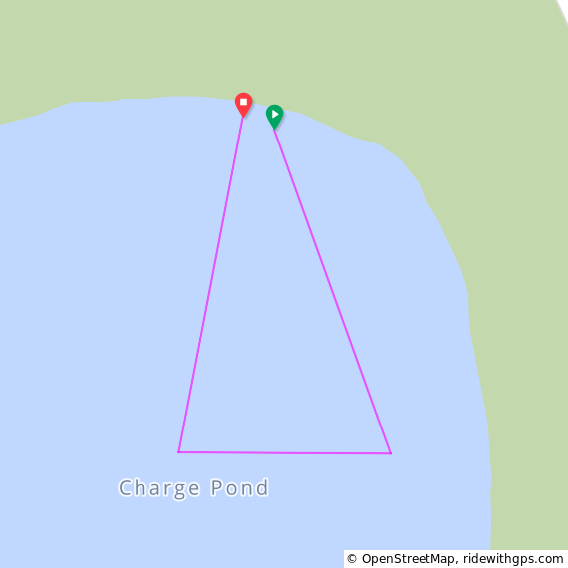
TRI FOR HEROS SWIM COURSE
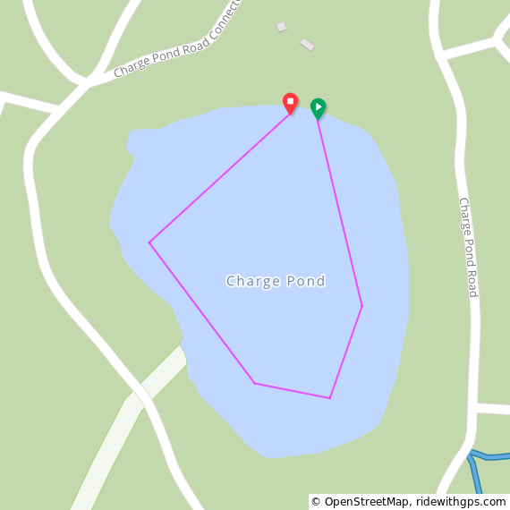
Super Hero Swim Hero Swim

TRI FOR HEROS MOUNTAIN BIKE COURSE

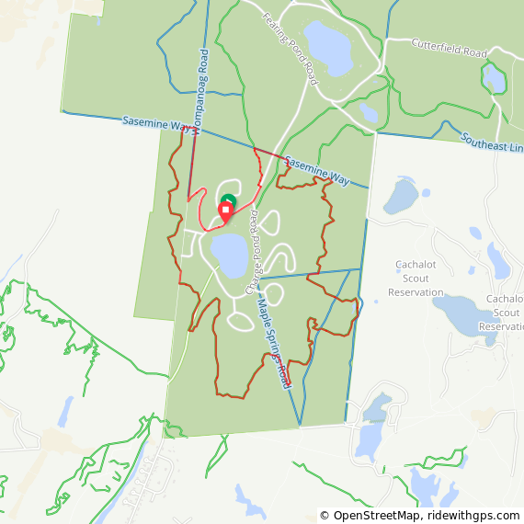
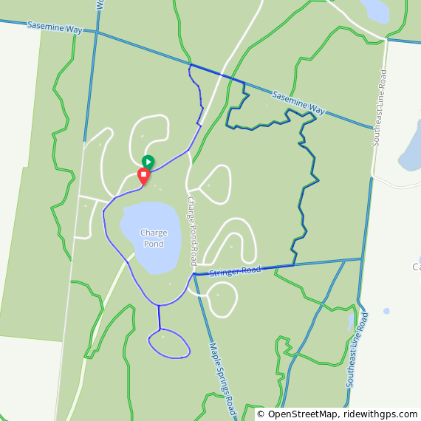
Super Hero Bike Hero Bike

